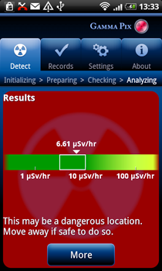
Radiation

How it Works
There are two ways to measure particle radiation and gamma rays. One can obtain a plug-in module that converts your smartphone into a Geiger Counter, or one can use the smartphone camera as a track detector. Each method has its advantages and disadvantages. For more information about background radiation, sources and units take a look at the SpaceMath@NASA ‘Radiation Math’ book at
https://www.nasa.gov/audience/foreducators/topnav/materials/listbytype/Radiation_Math.html

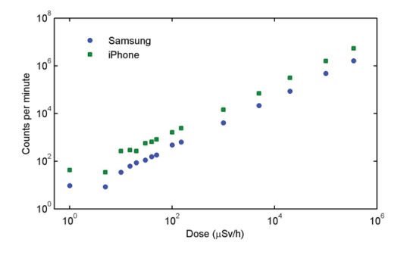
Camera methods involve closing off the front and back camera apertures so that the camera chip is in fully-dark mode. Cosmic rays, or other high-energy particles will collide with one or more pixels in the camera array chip and cause them to ‘light up’ with excess charge. Once the data has been corrected for the unavoidable ‘dark noise’ from the pixels themselves, the result is a count of the number of hits per sampling interval. This can be related to the level of radiation measured in μSieverts/hour in your environment after calibration.
External sensors – These usually plug in to the audio jack of your smartphone. They are small-volumed solid-state devices that react to energetic particles by producing a voltage or current spike that is picked up by the audio jack and counted.
Note that during a single year, you receive about 380 milliRems of accumulated radiation dose (3,800 μSieverts), which corresponds to a dose rate of 0.4 μSv/hr. Most apps provide dosage measurements in the SI units of μSv/hr. During the Fukushima reactor meltdown in Japan, residents in Tokyo some 239 km away, temporarily experienced levels of 0.8 mSv/hr. If you are traveling in a commercial jet at an altitude of 33,000 feet, you can expect a dose rate of about 2 μSv/hr for equatorial latitudes and about 7.0 μSv/hr for polar latitudes.
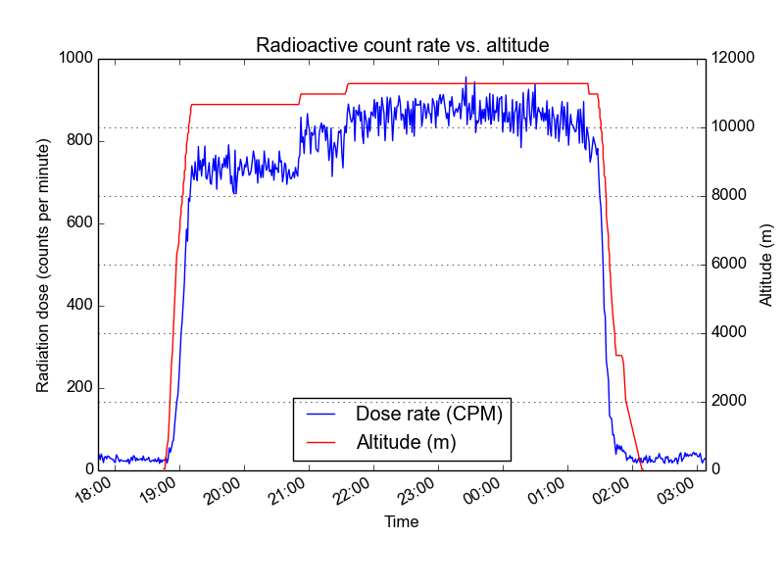
The radiation that is found at jet aircraft altitudes (|6.1 to 18 km) is produced from the interaction of primary galactic cosmic ray (GCR) particles with the Earth’s atmosphere. The GCRs consist of |90% protons, 9% alpha particles and 1% heavy nuclei typically ranging from carbon to iron(12). Most of these particles have energies between 100 MeV and 10 GeV, which can extend up to 10²⁰ eV(12). For example, the city of Denver in the United States (at 1650 meters elevation) receives a cosmic ray dose roughly twice that of a location at sea level. This radiation is much more intense in the upper troposphere, around 10 km altitude, and is thus of particular concern for airline crews and frequent passengers, who spend many hours per year in this environment. During their flights airline crews typically get an extra dose on the order of 2.2 mSv (220 mrem) per year. When you’re in an airplane, high above the Earth, you receive much higher radioactive doses from cosmic rays than people on the ground. In fact, commercial airline workers who are on planes for up to 900 hours per year, receive among the highest occupational dose of any occupation, coming in just below uranium miners with 3 mSv/year [2]. Note that nuclear power plant operators receive less than half of this. Just for fun, I thought I’d take some radiation measurements on a flight. I had to fly from Detroit to Paris for work recently, so I brought along my Geiger counter and GPS to keep track of radiation vs. altitude. Check it out: https://whatisnuclear.com/physics/radiation_on_flights.html Since this is a polar flight, the dose is higher than average for normal flights. A typical dose rate at cruising altitudes in polar regions is 7 µSv/h, while equatorial flights would be more like 2.5 µSv/h. This means that you’d have to be in the air in polar regions (US to Europe, etc.) for about 21 hours to get the same dose as a full mouth series of dental X-rays (150 µSv). The average background + medical + occupational dose to someone in the US is 6240 µSv/year or 0.7 μGy/hr.
http://news.spaceweather.com/2015/10/
On the evening of Sept. 27th, Spaceweather.com and the students of Earth to Sky Calculus conducted a routine flight of their cosmic ray payload to the stratosphere. Routine, that is, except for one thing: the balloon flew at night during a lunar eclipse. One of the goals of the flight was to compare radiation levels at night to those recorded during the day. Here are the data they recorded: 1 μRad/hr = 0.01 μGy/hr so the range of the measurements is from 0 to 4.5 μGy/hr. So the graph below shows that at 35,000 feet, the dose rate is 166 μRads/hr or 1.7 μGy/hr. The second graph shows a higher rate of 3 μGy/hr.

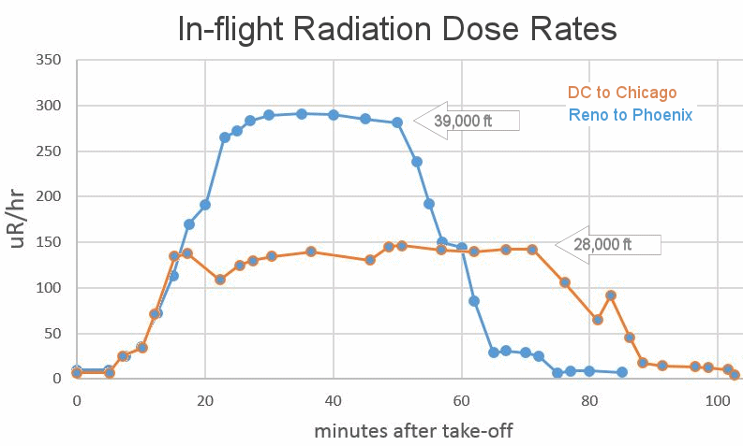
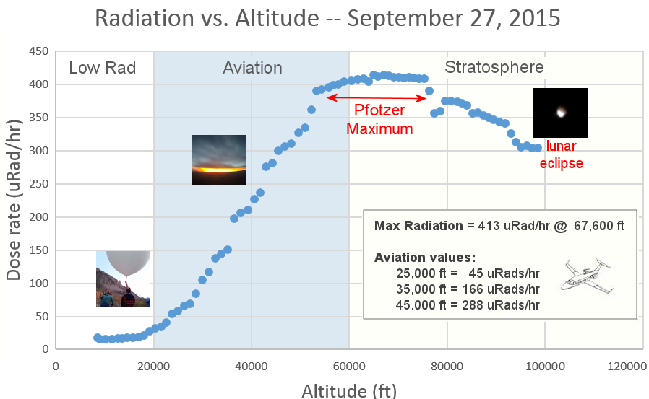

App Descriptions

GammaPix (iOS and Android)- $4.99 works with your smartphone's camera to detect radioactivity. The app allows you to measure radioactivity levels wherever you are and to be assured that your local environment is safe. The app can be used for the detection of radioactivity in everyday life such as exposure on airplanes, from medical imaging devices or from contaminated products. You can also use GammaPix™ to detect hazards from unusual events, such as nuclear accidents of the kind experienced in 2011 in Fukushima, Japan. http://www.gammapix.com/sites/
RadioactivityCounter (iOS – Android) - $4.99 This application is a real working radioactivity counter without any extra hardware needed ! It will turn your phone camera into a Geiger Müller Counter to measure radioactivity after proper calibration. The camera sensor can measure gamma radiation (Cesium-137 for example) and some beta radiation (depends on the energy if the beta rays can pass through the plastic parts - for example Helium-3 or potassium-14 are weak sources). It cannot measure alpha rays (Polonium-210) which will be blocked by the smartphone case.
https://itunes.apple.com/us/app/radioactivitycounter/id464004677?mt=8
Pocket Geiger Radiation Detector (Android, iOS) uses an external solid-state sensor that costs $92.00 to measure ambient radiation. Product Name: Smart Radiation Detector Pocket Geiger Type 4. Measuring Range: 0.05 µSv/h to 10 milliSv/h (Cs-137), 0.01cpm to 300kcpm. https://www.amazon.com/Radiation-Detector-Pocket-Geiger-devices-Turn/dp/B00B1TLQY8/ref=pd_lpo_107_tr_t_2?_encoding=UTF8&psc=1&refRID=16TB8AARW53J9TQSBBEE
Smart Geiger Radiation Counter - "Gamma" and "X-Ray" Detector, use of Smartphone Earphone Jack(3.5φ) Smartphone App "smart Geiger" in Android Play Store or Apple App Store. For Smartphone of Andriod, or IOS(iPhone, iPad). Real-time display of measurement results using Smartphone App "Smart Geiger" Sensor cost $24.00 from Amazon. https://www.amazon.com/Radiation-Detector-Smartphone-Earphone-Semiconductor/dp/B00O2AEQKY

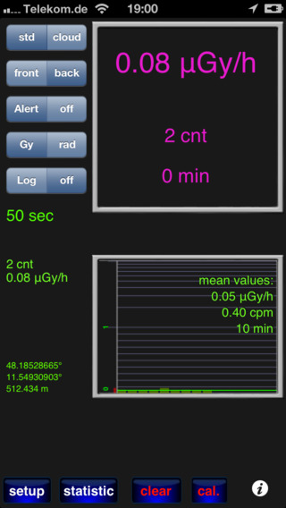
Relative Performance Tests
Radioactivity Counter setup – Cover camera lenses with black electrical tape. Run calibration routine…Takes 130 seconds, then it asks how long to take a data sample…select 10 minutes…it will take 10, 1-minute samples on a countdown timer. This is long enough for at least one count to register on the camera array to get a valid dose and count-per-minute (CPM). The display will indicate the ‘mean values’ in terms of CPM and μGreys/hr. It will also give a bar graph of the counts in each 1-minute sampling period.
Step 1 – select the ‘front’ camera, select the Alert ‘off’. Select ‘Gy’
Step 2 – Cover the camera lenses completely with black tape so that the top right camera screen is completely dark. You may also want to perform this calibration work in a darkened room to avoid stray light. Do not move the smartphone during the calibration process. Also, do not use an unventilated basement room because radon gas is common and will skew the baseline measurements to a higher background level in the calibration process. Also, place the smartphone on a wood surface or table top, but not on a granite counter since granite contains radioactive elements.
Step 3 – Calibration: Press the ‘clear’ button and the ‘cal’ button on the lower right, the app will go through a pre-programmed process and count-down for 90 seconds with ‘wait…calibration’ on the screen. At the end, it will then show a screen where you choose a 4-minute or 10-minute calibration run. Select ‘10-minutes’. It will then cycle through 10, 1-minute sampling periods. In each 1-minute period it will tell you the number of gamma-ray flashes it counted.
Step-4 – At the end of calibration, a message appears describing how the information has been saved. Click ‘OK’. On the main screen, click ‘clear’. The app will pause, then begin taking a series of 1-minute samples until you stop the app. After each minute it will update the values in the top-right screen with the measured background values. Let the app run for 5 or 10 minutes in order to build up reliable statistics since you will typically only be detecting a few counts every minute.
Here is a sequence of 1-minute counts: 2, 3, 2,2,1,4,0,5,1,7,2,3,5. Ave = 3 cpm so the dose rate is 0.09 μGy/hr.
[Conversion factors: 0 cpm = 0.05 μGy/hr 2 cpm = 0.07 μGy/hr 4 cpm = 1.33 μGy/hr 5cpm=2.57 μGy/hr ]
Note: There was no measurable difference using granite kitchen counter top or basement wood bench.
Location | CPM | μGy/hr | Location | CPM | μGy/hr
Inside car at Grosvenor | 1.7 | 0.060 | Mt Greylock (1048 meters) | 2.3 | 0.08
Inside car on Beltway 25 min | 1.4 | 0.060 | Over Virgiana (8800 meters) | 8.0 | 6.0
Goddard outdoors | 2.5 | 0.090
Home on Table | 3.0 | 0.090
Brad Davey (13,000 meters) | 55.3 | 74.3
New Jersey (13 meters) | 2.8 | 0.08
New York (31 meters) | 1.4 | 0.06
New York (52 meters) | 1.9 | 0.07
Williamstown (190 meters) | 1.7 | 0.06

Brad Davey flew from LA to Houston at 39,000 feet.
Sten Odenwald Items in yellow were on a drive from Home to Williamstown. Measurements were based on 10-20 minute span of measurements. Odenwald also flew from Baltimore, Maryland to Charlotte, North Carolina at 36,000 feet and measured 11 cpm (10 μGy/h), 8 cpm (6.3 μG/hr) and 4.5 cpm (1.95 μG/hr) for an average of 8 cpm and 6.0 μG/h. This is significantly higher than at ground-level (2cpm and 0.07 μG/h).
Series from the summit of Mt Greylock: Counts = 0,4,1,2,2,2,2,2,4,1 ave= 20/10 = 2 counts/minute so dose=0.08 μGy/hr. Actual from longer series = 2.3 CPM and 0.08 μGy/hr. The 1000-meter elevation change does not affect the CPM compared to similar levels recorded in Williamstown at 190-meter elevation. Here is the count series for Williamstown spanning 30 minute CPM averages.

Absolute Performance Tests
According to a youtube.com measurement of the app, it performs very well from 0.1 to 300 μSv/hr but at the low levels you must integrate for ten minutes to get a reliable dose value. The designers say that it is difficult to measure radiation between 1 to 10 μSv/hr. https://www.youtube.com/watch?v=rNe1UBfJvoo
In the YouTube program, the app was compared to several known radiation sources. More details about sensitivity and calibration can be found at the developer’s website including the CPM to μSv/hr conversion curves for various smartphones. http://www.hotray-info.de/html/radioa_ios.html
Background in Denmark: 0.16 μGy/hr and 11 cpm (17, 5, 10, 12 in 1-minute samples) was registered on the app and a similar reading registered on professional dosimeter.
Cesium-137 was used = 3.17 μSv/hr and 3.25 μSv/hr on two professional dosimeters. After 5 minutes, the app registered CPMs = 27, 38, 109, 47, 42 with average = 51 cpm and a dose of 4.95 μGy/hr.

Professional radiation dosimeter
Mazur Instruments PRM-9000 Geiger Counter and Nuclear Radiation Contamination Detector and Monitor, 0.001 to 125 mR/hr Range, +/-10 Percent Accuracy $595.00
https://www.amazon.com/exec/obidos/ASIN/B008TVSQU8/ezgeigercounters-20
The PRM-9000 includes the same two-inch (50.8 mm) pancake Geiger detector tube that is the gold-standard for surveying areas for potentially harmful ionizing radiation levels and for detecting radioactive contamination of packages, items, equipment and people. The instrument is suitable for regulatory inspections, and for the detection, measurement and monitoring of broad spectrum, low energy radionuclides, including Naturally Occurring Radioactive Material (NORM). The two-line, alphanumeric display supports both English and Japanese languages promoting ease-of-use and concise measurement. The display is backlit to support low-light conditions. Using only one key, users can scroll through several screens that display present, average, maximum and minimum measurements in uR/hr, mR/hr, uSv/hr, Counts per Second (CPS) or Counts per Minute (CPM).
The PRM-9000 instrument not only records the maximum radiation measured, but also displays the time and date at which the maximum occurred. Battery life is over 4-years under normal conditions from a single, readily-available, 9-volt lithium battery that is user-installable without soldering. Standard alkaline 9-volt batteries available everywhere provide over 2-years of life under normal conditions. With over 100K bytes of data logging memory included, the PRM-9000 can autonomously store up to 91,466 minutes or hours of time-stamped measurements. These measurements can then be uploaded to a PC in CSV format for analysis. A user-settable dose rate alarm sounds an audible alert when the measured radiation level exceeds that of the alarm level setting.
Designed by Mazur Instruments and manufactured in the USA, the PRM-9000 includes abundant I/O options including support for headphones, external speakers, external power and PC/Mac USB data exchange (requires optional 3.5mm to USB adapter cable). Minimum energy sensitivity alpha (2.5 MeV), beta (50 keV), gamma/X rays (10 keV). Gamma sensitivity: 3,500 CPM/mR/hr (Cs-137).

Comparison of Smart Geiger and Radiation Counter with Mazur.
The radiation apps and the Mazur dosimeter were compared in a variety of accessible environments to establish their consistency. Because the count rates were very low, the measurements shown in Table 2 were carried out for an hour, and the count rates averaged to obtain a root-N measurement precision of approximately ± 10%. An important caveat is that the count rates in CPM between systems with differing sensors cannot be directly compared. The number of counts or interactions between the radiation and the sensor depends upon such factors as the surface area or volume of the detector, and the method of the interaction. The Mazur dosimeter is triggered by conducting, ionized tracks appearing between two high-voltage plates as the particle passes through the detector, while Radiation Counter and Smart Geiger rely on direct charge deposition within the sensor volume. The resulting CPMs cannot be directly compared, however each system is calibrated by the developer by comparing the system’s CPM against a set of test sources that deliver a calculated dose rate in μSy/hr, so that the dose rates reported by each system can be directly inter-compared. The way in which this is done can be demonstrated by the following mathematical analysis (RSSC, 2011). We will use gamma-rays because they follow the inverse square law. For example, if a dose rate of 100 μSv/hr is detected at 1 meter from a point source of gamma-rays, the dose rate at 10 meters will be 100 μSv/hr / 102 = 1 μSv/hr.
A radioactive sample of Barium-133 is a pure gamma-ray source that can be purchased from Images Scientific Instruments and is rated at 1.0 μCuries. This radioisotope has a measured ‘old style’ physical activity constant of G = 2.4 Roentgens centimeter²/milliCurie hour. The amount of activity in the sample is measured in Curies, which is a unit of disintegration such that 1 Curie equals 3.7x10¹⁰ disintegrations per second in the sample. Suppose that the calibration sample is 30 centimeters from the sensor, then the dose rate would be D = 2.4 x 0.001/30² = 2.7 μRoentgens/hr. Converting this to SI units of dosage, 1 Roentgen = 0.01 Grays, but for gamma-rays the Quality Factor is 1.0, so 1 Grays = 1 Seiverts, and so the estimated dose rate of the Barium-133 sample is just 2.7 μRoentgen/hr x (0.01Seiverts/1 Roentgen) x (1 hr/60 minutes) = 0.044 μSv/hr.
An alternative method of calculating radiation dosage involves considering the energy of the gamma-rays and the gamma-ray yield of the source through the formula D = 6 CEf/d² in milliRad/hr where C is the activity in milliCurties, E is the energy of the radiation in MeV, f is the fraction of disintegrations that produce the specific radiation, and d is the distance to the source in feet (RSSC, 2011). For example, Cesium-137 produces 1.17 Mev beta particles at 5% yield and 0.66 MeV gamma-rays at 90% yield. If we have a 1 milliCurie source at 1 meter (3 feet), the dose rate for the gamma-rays would be D = 6 (1.0 milliCu)(0.66 meV)(0.90)/(3 feet)² = 0.066 milliRads/hr, which for gamma-rays with Q=1 and 1 rad=0.01 Seivert, equals 6.6x10⁻⁵ Rads x 0.01 (Sieverts/Rads) = 0.66 μSv/hr.
The above dose rates are only upper limits because they do not include the interaction of the radiation with the material surrounding the sensor, or the sensor itself. To account for the reduction from shielding and interaction with the sensor requires a much more complex calculation beyond the scope of this paper, but which are a part of the calibration process by the developers for each sensor system.
Table 3 – Representative environmental radiation dosages

Source | Mazur | Radiation Counter | Smart Geiger
Indoor table top | 36 CPM, 0.12 μSv/h | 2.1 CPM, 0.07 μSv/h | 1.0 CPM, 0.05 μSv/h
Outdoor back yard | 49 CPM, 0.14 μSv/h | 1.6 CPM, 1.5 μSv/h | 0.1 CPM, 0.05 μSv/h
Airport indoors | 32 CPM, 0.13 μSv/h | 1.3 CPM, 0.06 μSv/h | 0 CPM, 0.05 μSv/h
26,000-foot altitude | 100 CPM, 1.3 μSv/h | 2.2 CPM, 0.08 μSv/h | 6 CPM, 0.54 μSv/h
Granite counter top | 100 CPM, 0.28 μSv/h | 3.8 CPM, 0.07 μSv/h | 1.5 CPM, 0.12 μSv/h
30,000-foot altitude | 71 CPM 2.4 μSv/h | 2.6 CPM, 2.5 μSv/h | 80 CPM, 2.0 μSv/h

We see in Table 3 that the first three ground-level dose rates for each system report quite different values for the background rate: Mazur (0.13 ±0.01 μSv/h), Radiation Counter (0.5 ±0.5 μSv/hr) and Smart Geiger (0.05 μSv/hr). The Mazur sensor is able to easily detect the background rate, but the two smartphone systems yield conflicting values and low detection significance. At 26,000 feet and above, however, all three systems are easily able to detect the increased ambient radiation at aviation altitudes, however the smartphone systems disagree as to the exact level at 26,000 feet where the dose rats is near 1.0 μSv/hr, but are in greater concordance at 30,000 feet where the level is only slightly higher at 2.4 μSv/hr as indicated by the Mazur sensor. It appears that there is a detection threshold for the two different smartphone sensor systems at about 0.5 μSv/hr, with higher dose rates being more consistently and accurately detected. Consequently, these systems respond to naturally-occurring background conditions only above an altitude of 26,000 feet. It is possible, however, that repeated measures by these systems over much longer time periods of hours to days may obtain better dose detection through data-averaging so long as the radiation process behaves in a Gaussian manner so that the variance (σ²) of the average decreases inversely with the number of samples combined.

