Magnetism
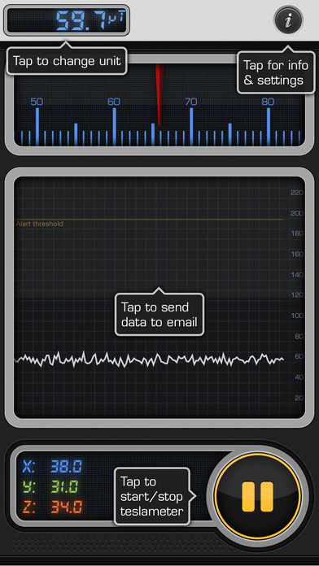

How it Works.
Smartphones come equipped with a magnetometer so that your phone can sense its orientation in space, and use basic apps like the Compass App to determine your location with respect to Magnetic North (or South!). The way this is done is through an internal chip that contains a 3-axis magnetometer. This magnetometer consists of three separate modules internally aligned separately on the x, y and z axis of the smartphone. Each of these three sensors measures the intensity of Earth’s magnetic field (or a local source of magnetism like a bar magnet) along only one axis using a Hall Effect sensor. Hall Effect sensors create a changing output voltage as the magnetic field that passes through them changes in strength. Various magnetoresistive materials are used to confine the response of each sensor to only one dimension of the applied field. It is generally recommended that you stay far away from really strong magnetic fields like bar magnets or medical scanners because these can cause the magnetometer to overload and it takes up to 30 minutes for it to once again re-acquire Earth’s much weaker magnetic field to resume its orientation calculations used in other apps and features.
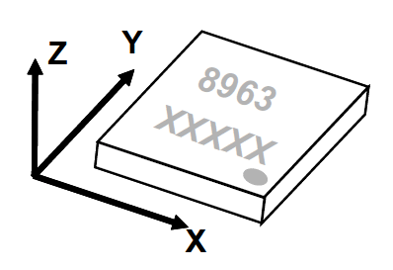
An example of such a magnetometer sensor is used in the Moto G smartphone and is provided by the AK8963, 3-axis Electronic Compass IC. (https://www.akm.com/akm/en/file/datasheet/AK8963C.pdf). This is a silicon monolithic Hall-effect magnetic sensor with magnetic concentrator, which creates a 3-axis magnetometer on a silicon chip. These chips are incredibly inexpensive and only cost about $1.00 per smartphone! The AK8963 chip’s measurement range is from -4912 μT to +4912 μT (-49 Gauss to + 49 Gauss). The voltage generated is in analog form so an on-chip analog-to-digital converter converts the output to either a 14-bit or a 16-bit data word. Output data resolution is 0.6 μT per bit for the 14-bit resolution model, and 0.15 μT/bit for the 16-bit model. In continuous measurement more takes 8 samples per second for regular resolution and 100 samples/sec for high resolution measurements. AK8963 has the limitation for measurement range that the sum of absolute values of each axis should be smaller than 4912μT, or in other words |X|+|Y|+|Z| < 4912μT. The displayed X,Y,Z axis are based upon the orientation of the chip in the phone and align with the so-called Body Frame coordinate system. Generally, the +Z-axis is pointing away from the front and is always perpendicular to the face of the iPhone. The X-axis is along the short length to the right, and the Y-axis along the long length. The orientation of the axes follows the Right-Hand Rule. Geophysically, we work in the Earth Frame where the x-axis always points to magnetic north and is contained in the local horizontal plane. The y-axis always points east and also in the horizontal plane. The z-axis always points down and of course is perpendicular to our horizontal plane. Smartphones use rotation matrices to convert from the Body Frame to the Earth Frame systems and thereby determine the orientation of the smartphone in physical space.

App Descriptions
The following apps often use micro-Tesla as a measurement unit. Sometimes the symbol μT is shown with the data but often times it is not. Some units also allow you to switch between μT and Gauss units. 1 μT = 10 milliGauss. Earth’s magnetic field has an average strength of 65 μT or 0.65 Gauss (650 milliGauss). All of these Apps use the internal, 3-axis magnetometer built into the circuitry of modern Smartphones to measure this field in 3-D. This built-in magnetometer is typically used for compass apps and other, non-GPS direction finding tools.
Teslameter 11th (Android; iOS) – Takes advantage of the built in magnetometer in your iPhone/iPad, allows you to monitor the strength of magnetic field. Displays the raw 3 axes x, y and z magnetometer values; Record and export the data to email for further analysis. https://itunes.apple.com/us/app/teslameter-11th/id473154714?mt=8

Tesla Recorder (Android; iOS) - Uses the magnetometer sensor of your mobile device to transform your phone or tablet into a fun and easy to use metal detector / electromagnetic scanner. Automated recording for long-time measurements; Diagram showing real-time measurement of electromagnetic field strength in all three dimensions (x, y, z). https://play.google.com/store/apps/details?id=com.exelerus.apps.tesla
Sensor Kinetics (Android; iOS) – See your iPhone in motion! Watch your iPhone's gyroscope and accelerometer sensors in action and discover how they work. Measure the effect of gravity on your iPad and experiment with its magnetometer. Sensor Kinetics is a complete Physics class about all of the motion sensors on your iPhone or iPad. Scroll up and down the Sensor Kinetics screen to see the many motion sensors in your iPhone. The advanced viewers show real-time measurements from all of the standard sensors available in your iPhone or iPad, including the gyroscope, accelerometer and magnetometer. Sensor Kinetics provides a comprehensive look at the combined operations of all the kinetic (motion) sensors. Tap the sensor title line with the chart icon to activate the chart viewer. Each chart viewer provides detailed scrolling graphs for the three relevant axes of the associated sensor. In the case of the accelerometer, the chart viewer has two modes. In raw data mode, it produces a graph of the accelerations along the X,Y,Z axes, while during Rotation data mode, the app computes the actual roll and pitch angles as they accumulate while you rotate and move the device. Who Should Use Sensor Kinetics? Developers, students, hobbyists... anyone who's curious about what lies "under the hood" of their iPhone or iPad! It will tell you exactly what motion sensors you have on your iPhone and what the sensors are measuring. https://itunes.apple.com/us/app/sensor-kinetics/id579040333?mt=8

Finding the Smartphone Magnetometer
Warning: You should not expose your smartphone to strong magnetic fields for extended periods of time. It will recalibrate the magnetometer and will stop it from working. It will take days before the system gets recalibrated to earth’s magnetic field, and if you accidently magnetize some of the internal metal parts your magnetometer apps will never work properly.
The biggest technical challenge to mapping magnetic fields with a smartphone is that your smartphone is physically much larger than the magnet whose field you are trying to map. For the case where the smartphone is much smaller than the grid spacing you are sampling, there is no need for a detailed knowledge of the sensor location inside the smartphone case. This applies to mapping the geomagnetic field over meter-scales. This may also apply to the recent surge in interest in determining a customer’s location in a store by creating an indoor map of the magnetic environment and then measuring the customer’s magnetic coordinates. But when we want to map the field of a small object like a bar magnet, to make an accurate map, you need to know exactly where the smartphone’s magnetometer is located inside its case so that you can define what spot in space is being measured relative to your magnet. It would be nice if the magnetometer was located directly under the exact center of the case, but typically they may be located anywhere within the body of the phone from one model to the next!
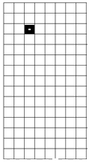
Measurement of the magnetic field of small magnets with a smartphone: A very economical laboratory practice for introductory physics courses’ Enrique Arribas, Isabel Escobar, Carmen P Suarez, Alberto Najera and Augusto Beléndez. Article · Eur. J. Phys. 36 (2015) 065002 (11pp) October 2015 DOI: 10.1088/0143-0807/36/6/065002 https://www.researchgate.net/publication/281427984_Measurement_of_the_magnetic_field_of_small_magnets_with_a_smartphone_A_very_economical_laboratory_practice_for_introductory_physics_courses
Mapping your magnetometer using a jeweler’s screwdriver!
A typical magnetometer ‘chip’ on a smartphone circuit board is only a few millimeters square. Smartphone apps that detect pipes in the wall or electrical wires use the magnetometer as a sensor. If we use a very thin metallic object (iron nail, jeweler’s screwdriver) we can hover it over the surface of the smartphone and locate the chip to millimeter-accuracy by watching the Bz values suddenly increase to a maximum.

Noise Measurements
The Tesla Recorder app was used to make repeated Bx, By, Bz and |B| measurements over a period of ten minutes to assess the rms noise and noise spectrum properties of a ‘typical’ iPhone magnetometer. For the N=1160 samples taken every half- second (f=2 Hz) we obtain the following plot of |B|.

The straight-average was 55.41 μT and the rms was 0.21 μT. Similar statistics were computed for N=10 and N=100. For which the rms values obtained were 0.21 μT and 0.18 μT respectively. There is no expected root-N reduction in the noise even over this interval. This implies that the magnetic sensors are white noise-dominated at a level of 0.2 μT and does not represent Gaussian noise for which 1/root-N improvement can be expected.

In this graph you can also see the digitization ‘step’ levels which are about 0.15 μT in size. This happens because the analog-to-Digital converter in the smartphone has a 15-bit range so that 1-bit, the smallest recorded interval, is 0.15 μT in size.

