Light Intensity
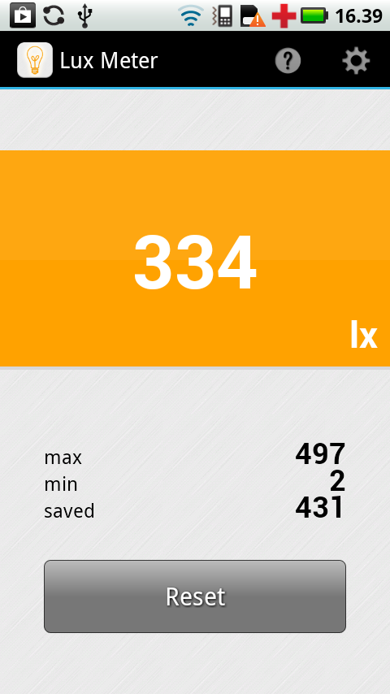

How it Works
Smartphones use light meters to set the exposure speed and the ISO ‘film speed’ of the digital camera. These metering systems are created by ‘spotting’ the pixels in a portion of the camera array chip to measure the incident light that falls on them. This information in the ‘spot metering’ mode is used to set the exposure speed of the camera. The f-stop of a smartphone camera is fixed usually at f/2 (fast) or f/2.4 (slow) or so, unlike in digital cameras. The roughly half-stop difference in cameras corresponds to the faster cameras seeing 50% more light, and so they perform better under low light level conditions.
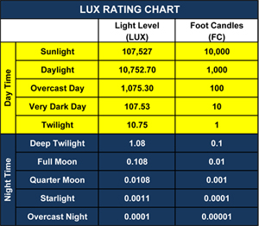
Smartphones also use ambient light sensors are stand-alone devices to determine how bright the display needs to be for comfortable viewing. These sensors are not very directional unlike the camera light metering system. Most smartphone ambient light sensors are photodiodes whose current flow varies with the amount of applied light.
The following apps measure light intensity in terms of illuminance in units of Lux. Physically, illuminance is related to the flux of radiant energy per square meter, and is the product of the emission spectrum and the normalized spectral response function of the human eye, and summed over all wavelengths to get the total energy flux.
Because the flux of sunlight during noon daylight conditions is about 100,000 Lux, and this corresponds to a solar insolation of about 1000 watts/m², we can estimate that 1 lux = 100 watts/m². A 60-watt incandescent light bulb might generate 850 lumens. But since 1 lux = 1 lumen/1 m², if the bulb is at the center of a sphere with a surface area of 16 square meters, you have 850/16 = 53 lux. Generally a 60-watt bulb does not produce 60 watts of luminous energy but significantly less, so the conversion factor above does not apply.

App Descriptions
LuxMeter Galactica – ($1.99) If you professionally deal with lighting or simply want to measure the illumination of the certain place, and you do not have a special device, you can use this application to make light measuring, combine the values ​​obtained (lux) with a photo of your place of measurement, add your comments and save your image in photo album or send via e-mail. This app is used for evaluative light measuring and is not a substitute for specialized device.
Light Meter (free) by Butta. A camera view allow you to view the area you want to measure. You can choose between the front and rear camera. Additionally the shutter speed, ISO and focal are displayed.

Relative Performance Tests
Check to see if apps give consistent reading for same brightness. Static measurement of identical light source. Camera sensor facing white poster board placed horizontally outdoors on a cloud-free day and filling FOV of camera.
App  Name/icon | Metering  Method | Pitch black room | March 24  2:00pm  sun @ 52º | March 24  3:00pm  Sun @ 48º | March 24  4:00pm  Sun @ 35º | March 24  5:30pm  Sun @21º
 | Camera view  $1.99 | 7 lx | 202,000 | 177,000 | 78,600 | 42,900
 | Camera view  Free | 0 lx | 212,738 | 186,137 | 87,595 | 48,023

Absolute Measuring using Professional-grade Photometers.
The difference between the camera apps and professional metering systems is that the apps use the primitive light sensor on the camera while the professional systems use a high-grade photoconductor system and filtering system to make the measurements.
We need to measure our meters at levels above 10,000 lux for solar daytime conditions. For this we used a professional-grade light metering system: Extech Instruments LT300 Light Meter (Amazon: $129.00). The Extech LT300 light meter measures up to 40,000 Fc (or 400,000 Lux) utilizing a remote light sensor connected via 12 in. coiled cable (expandable to 24 in.). An LCD readout displays a digital calculation and complementary analog bar graph for quick assessments. (http://www.extech.com/resources/LT300_UM.pdf). Measurement repeatability is claimed to be +/- 2% and accuracy +/- 5%.
Next we measured a standard 60-watt bulb placed at different distances from the smartphone and the professional metering systems. The set up was in a darkened room where only the light bulb provided the illumination. This was repeated four times with four different 60-watt bulbs.
App | Bulb A | Bulb B | Bulb C | Bulb D | Averages with  +/- 1 sigma
Lux Light meter -2 | 218 | 354 | 218 | 281 | 267 +/- 64
Galactica -1 | 216 | 276 | 345 | 276 | 278 +/- 53
Extech | 403 | 403 | 403 | 405 | 403 +/-1

The grand average for the five apps is 276 +/- 50 Lux but Extech says 403 +/- 1 Lux so at this light intensity, the scale factor Extech/app = 1.47+/-0.25 so that the apps predict a 47% lower Lux than the professional metering systems. It is also interesting that the watt-meter says that a 60-watt bulb produces 22 watts/m² of illumination.
Check linearity of the scale factor by using inverse-square law with one 60-watt bulb for all metering systems. The decrease at each step by a factor of two should be a factor of 4 in lux
App | Zero Light | 9-inches | 18-inches | 36-inches | 72-inches | 144-inches
Lux Light meter -Lux | 0 | 2314 | 445 | 107 | 37 | 27
Galactica | 0 | 9000 | 552 | 138 | 46 | 34
Extech | 0 | 1580 | 386 | 97 | 39 | 16

Plotted points are only those from within 36-inches of the bulb to avoid background scattered light that artificially elevates the lux values. The best-fit linear equation shows that the power-law exponent is very close to -2.0 for the Lux vs distance (upper line) and flux vs distance (lower) data so the inverse-square law is verified to within the measurement errors so long as the light intensity remains above about 100 Lux.
As before, the smartphone app light meter measurements were made sequentially, with the camera lens facing a horizontal, white sheet of paper in full sunlight. The Extech and DT-3701 meters were then placed at the center of the paper with the sensors facing up and pointing to local zenith. A variety of external light measurements were made of direct and indirect sunlight.
Type | Extech | Lux Light meter | Galactica
direct | 16 | 27 | 31
direct | 39 | 37 | 43
direct | 97 | 107 | 135
indirect | 130 | 173 | 138
direct | 386 | 445 | 549
indirect | 1150 | 1153 | 1700
indirect | 1709 | 2392 | 2300
indirect | 3125 | 4560 | 5000
indirect | 3462 | 6500 | 6000
indirect | 4430 | 8490 | 8600
indirect | 6700 | 14879 | 14700
direct | 13800 | 28082 | 26200
direct | 21600 | 59562 | 54400
direct | 36000 | 87595 | 83200
direct | 58200 | 114544 | 118000
direct | 68200 | 165461 | 141000
direct | 70000 | 165461 | 177000

The response of each app relative to the calibrated Extech scale were plotted and fitted. The following two plots are for the camera imaging systems where you can clearly see the light source on the screen with the metering circle drawn around the center.

It is clear that these apps yield a uniform scaling that is between 2.25 and 2.36, which says that for bright light sources, the apps predict a Lux value that is about 2.3 times higher than an actual, professional light metering system over an illumination range from 0 to 70,000 Lux. This means it is a simple matter to take Lux values from a camera light app and convert it to an actual illumination scale by dividing the app values by 2.3.
If you want to convert your lux values into solar light power (watts/meter²) just divide the lux values by 115 to convert. Your electrical power from a solar panel will depend on the conversion efficiency….usually 70% for modern germanium-based panels and 15% for silicon-based panels. If your silicon-based panel is receiving 100000 lux then the electrical power will be 100000 x 0.15/115 = 130 watts/m² of electrical power.

