Gravity
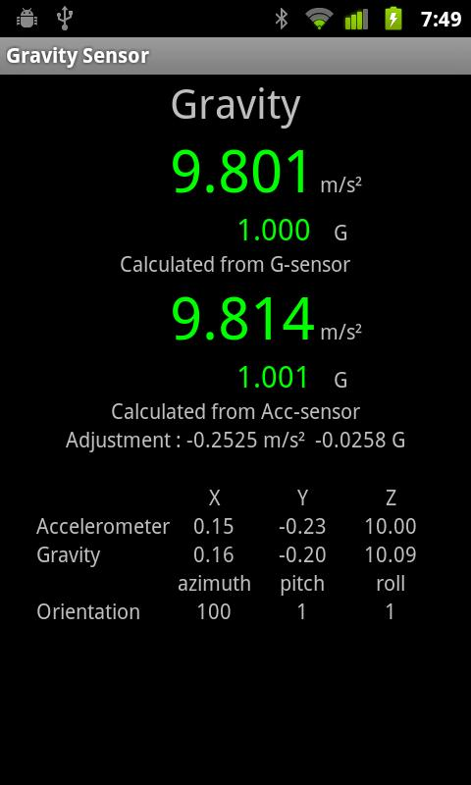
How it Works
The gravity sensor measures the acceleration effect of Earth's gravity on the device enclosing the sensor. It is typically derived from the accelerometer, where other sensors (e.g. the magnetometer and the gyroscope) help to remove linear acceleration from the data. The Gravity unit are in m/s² like the accelerometer, and they are measured along the X,Y, and Z axes. In modern mobile devices, the physical sensor that measure acceleration is the accelerometer. The accelerometer, however, measures all the accelerations that affect the device, which are the sum of the gravity acceleration and the actual linear acceleration that are associated with the movement of the device. A crude estimate of the gravity on hand-held device can be made on the accelerometer reading using a low-pass filter that minimizes the linear acceleration. Modern mobile devices refined the gravity measurement by creating a virtual sensor that is implemented as a sensor-fusion of several basic physical sensors, the accelerometer, the gyroscope, and the magnetic sensor.

App Descriptions
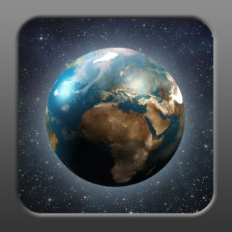
GravityMeter (Android; iOS) –This is a simple app that allows you to measure the effects of gravity. It displays how many G's you are experiencing and also what the gravitational acceleration is. Gravity varies due to many things. The most common factors that change the force of gravity is: Latitude, Altitude, The position of the sun and moon, The type/density of rock found in your area. Gravity Meter now shows the average gravitational acceleration of major cities around the world. Gravity Meter now has faster data collection on startup and adjustable accelerometer accuracy. The data measured by the accelerometer can be adjusted to be extremely accurate or to have a fast response time.
Relative Performance Tests
GravityMeter (iOS) - Place on a horizontal, flat surface so that the smartphones Z Body Axis is parallel to the up-down Z axis in the Earth Body Frame. Press the ‘calibrate’ key and let it run through its 60-second process. When it says calibration complete, shut off the app and re-start it. On the horizontal surface, it should come up in the ‘Your device is fully calibrated’ mode and show the two measurements in ‘Gs’ and in m/sec2.

Melissa Montoya 3/2 iphone n=38 | Hawaii | 19.89 | 9.786 | 9.809 | 9.711 | 9.788
Alfredo Medina - Android | Guatamela | 14.6 | 9.783 |  |  |  | 9.9 | 9.84 | 9.86
Alfredo Medina - iPhone 5 | Guatamela | 14.6 | 9.783 |  |  |  | 9.45 | 9.42 | 9.43
Patrick Morton - | Maracaibo, Veniz. | 10.2 | 9.781
Heather McHale ipad 2-air | Bogota, Columb. | 4.71 | 9.780 | 9.79 | 9.77 | 9.78
JP Rattner (android tablet) - Gravity Meter by andromart = 9.8067 – 9.8066 Ghanjah Android - 9.8066-9.8067
In column 4 I give the predicted acceleration using the formula
G = 9.806 - 0.5(9.832-9.78) cos(2 θ )
where θ is the absolute magnitude of the latitude. The assumed equatorial acceleration is 9.78 m/sec² and at the pole it is 9.832 m/sec².
I let my GravityMeter run for 5 minutes after turn on. It started at 9.80-9.81 and remained at this level throughout the 5 minutes at GSFC.
Black line is the predicted value and dashed is the trendline for the data assuming all points are equal-weighted. The 3 outliers above the mean line in the latitude range 30 – 43 are highlighted in the table above. These were all measured by Robert Gallagher in China (near 30 degrees) and Frankfort, IL (43 degrees).
The android phones do far worse than the iPhones:

Classroom data:
Sue Lamdin – Brunswick,ME Latitude = 43.88
Name | Model of Smartphone | Smallest number | Largest number | Most common number
Max | iPhone 5S | 9.86 | 9.87 | 9.87
Ethan | iPhone5 | 9.77 | 10.4 | 9.83
Julian | iPhone 7+ | 9.79 | 9.83 | 9.82
Delaney | iPhone6 | 9.81 | 9.84 | 9.82
Emily | iPhone SE | 9.82 | 9.83 | 9.82
Mrs. Lamdin | iPhone 6S | 9.8 | 9.82 | 9.81
Anna | iPhone6 | 9.8 | 9.82 | 9.81
Ophelia | iPhone 6S | 9.8 | 9.81 | 9.81
Simon | iPhone 6S | 9.54 | 9.82 | 9.8
Sara | iPhone 5C | 9.76 | 9.82 | 9.8
Lily | iPhone5 | 9.77 | 9.81 | 9.8
Sammie | iPhone 6S | 9.79 | 9.81 | 9.8
Brad | iPhone 5S | 9.79 | 9.83 | 9.8
Lilly | iPhone 5S | 9.78 | 9.81 | 9.79
Aiden | iPhone SE | 9.77 | 9.81 | 9.78
Emma | iPod6 | 9.77 | 9.79 | 9.78
Maddie | iPhone 6S | 9.74 | 9.77 | 9.76
Wilder | iPhone6 | 9.75 | 9.76 | 9.76
Tucker | iPod6 | 9.75 | 9.77 | 9.76
Loni | iPhone6 | 9.74 | 9.75 | 9.74
Hannah | iPhone 6S | 9.7 | 9.72 | 9.72
Julia | iPhone7 | 9.71 | 9.73 | 9.72

Black line is predicted value of 9.80 m/sec² at this latitude
Average of last column = 9.790 (9.764, 9.828) rms = 0.036 for 22 students.
Melissa Montoya Hawaii Latitude 19.89
NAME | PHONE | SMALLEST | LARGEST | MOST COMMON NUMBER
Peter Ramos | iPhone 6 Plus | 9.76 | 9.85 | 9.82
Bryson Raquini | Iphone 6s | 9.61 | 9.73 | 9.81
Nichole Batugal | iPhone 6s Plus | 9.79 | 9.83 | 9.81
Jeremiah Maglay | iPHone 7 | 9.77 | 9.83 | 9.81
Joshua Ponce | Iphone6s | 9.74 | 9.85 | 9.81
Braeden Bucao | iPhone 6s | 9.77 | 9.81 | 9.8
Jacob | Iphone 6s | 9.75 | 9.9 | 9.8
Shawn Mino | iPhone 6s Plus | 9.8 | 9.85 | 9.8
M. Montoya | iPhone 7 | 9.79 | 9.84 | 9.8
Mark Masaoay | Iphone6 | 9.78 | 9.81 | 9.8
Izaiah Felipe | iphone 6s | 9.77 | 9.81 | 9.79
Rianne Tangonan | iPhone 7 | 9.78 | 9.8 | 9.79
Dominick Quiamas | Iphone SE | 9.79 | 9.81 | 9.79
johnwin garcia | iphone6 | 9.75 | 9.83 | 9.79
Louie Fiesta | iPhone 6s | 9.76 | 9.8 | 9.79
Nathan | iPhone 5SE | 9.78 | 9.79 | 9.78
Skecynyth Perlas | Iphone 6s | 9.77 | 9.83 | 9.78
Jonathan Sabado | Iphone 7 plus | 9.72 | 9.8 | 9.78
Radlee Ferreira | Iphone6s | 9.76 | 9.79 | 9.78
Rico Galacgac | iphone 6s | 8.14 | 9.96 | 9.78
Kayle Aceret | iPhone 5SE | 9.76 | 9.83 | 9.77
Rondel Garcia | Iphone 6 | 9.76 | 9.81 | 9.77
joel pisavale auvae | iphone 6 plus | 9.75 | 9.79 | 9.77
Reynaldo Agustin | Iphone 6s | 9.72 | 9.77 | 9.77
Charize Balignasay | Iphone 6s | 9.76 | 9.79 | 9.77
Papaloa Leiu | Iphone6s | 9.69 | 9.8 | 9.77
Chase Macloves | iPhone 5s | 9.76 | 9.76 | 9.76
Russel Remigio | iphone 6 | 9.74 | 9.75 | 9.76
RJ SERNA | iPhone 7PLUS | 9.74 | 9.75 | 9.75
Ionakana freitas | iphone6 | 9.64 | 9.77 | 9.75
jordan Pajela | iphone6 | 9.73 | 9.76 | 9.75
Jhan Ray Corpuz | Iphone 6 | 9.71 | 9.73 | 9.74
Mark Dela Cruz | Iphone6s | 9.73 | 9.75 | 9.74

Average = 9.781 m/sec² (9.699, 9.805) rms = 0.022 m/sec² for N = 33 students.
Predicted value is 9.786 m/sec² at this latitude
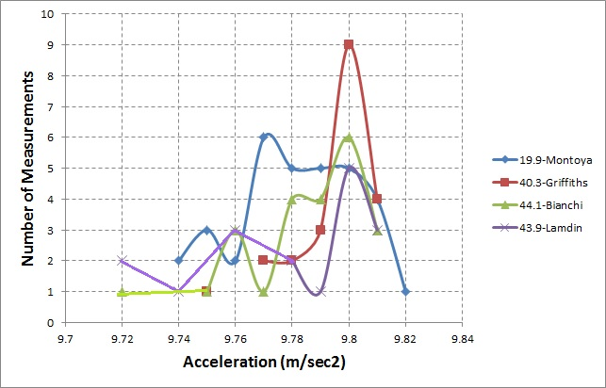

Android phones:
NAME | PHONE | SMALLEST | LARGEST | MOST COMMON NUMBER
Marie Agoto | LG G Stlyo | 9.49 | 9.82 | 9.5
NicoleAguinaldo | Note 3 | 9.72 | 9.9 | 9.9
Glenn Vite | Samsung 6 edge | 9.62 | 9.69 | 9.67
Tryton Austria | samsung grandprime | 9.64 | 9.81 | 9.7
Keanu Ruiz-Teixeira | Samsung j3 6v | 9.717 | 9.784 | 9.768
SYDAN CRISOSTOMO | SAMSUNG S7 | 9.627 | 9.696 | 9.689
joseph cachola | samsung s7 | 9.17 | 9.55 | 9.93
kyle villanueva | samsung s7 edge | 9.75 | 9.81 | 9.76
Jayden Domingo | samsung Vs500 | 9.79 | 9.81 | 9.70
KrisJay Domingo | Alcatel | 9.689 | 9.989 | 9.689
gabriel sotelo | galaxy core prime | 9.813 | 9.816 | 9.869
 |  | 9.639 | 9.789 | 9.657

Predicted value is 9.786 m/sec² at this latitude
Average = 9.752 m/sec² (9.639, 9.789) rms = 0.158 m/sec² for N=11 students
I calculated the normal average in column F, which I highlighted in yellow. In the blue-highlighted cell I calculated the standard deviation. The android phone SD is larger. But if I take into account the fact than more samples were used in the value for the iPhones (33 vs 11) that should only make the android phone standard deviation about 0.0216 x sqrt(33/11) = 0.037 which is still much smaller than the android phone value. That suggests that the android phones are about 0.158/0.037 = 4 times worse than the iPhones.

Another discovery made with the classroom data comes from Elizabeth Bianchi’s class who use iPads to make their measurements. She provided me with a time-tagged spreadsheet of the values made between 11:30 am and 1:10 pm local time and it demonstrated that there is a correlation:

This explains why so many of the classroom points were at values considerably lower than the peak near 9.8 m/sec² and made the distribution non-Gaussian. I suspect this heating effect is going on with the iPhone measurements, and this is why I have such a large variance in values at the same latitude.
Result for searching for Earth rotation:
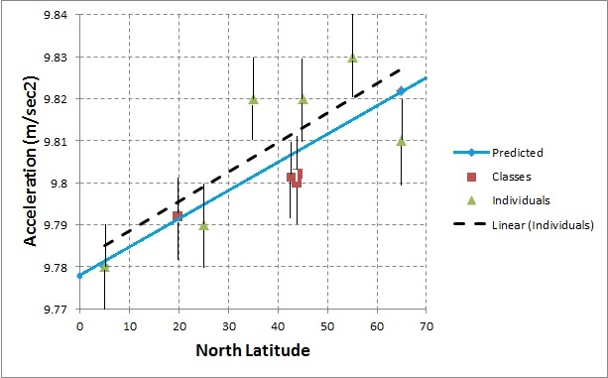
Blue line is the predicted actual change. In each 10-degree latitude bin I computed the median of the available measurements. The error bars represent +/-0.01 m/sec² which is the typical single-data point variation between max and min values seen. All that can be concluded with this small sample is that higher latitudes detect a slightly lower value for g than at lower latitudes, but the significance is not very great. Need more data and better controls on how data is taken. Classroom data shows large variations with same smartphone type from student to student that is 3x the range between max/min for any one measurement!
https://www.academia.edu/17804807/Study_of_Sensors_Embedded_in_Smartphones_for_Use_in_Indoor_Localization
http://rouel-projects.blogspot.com/p/calculations-with-iphones.html
http://www.rotoview.com/gravity_sensor.htm

