Investigating the Elliptical Orbit of the ***Parker Solar Probe***

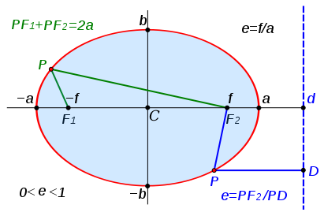

**Problem 1** – If the sun is located at the focus F1 in the diagram above, what is the distance between F1 and the left-hand point labeled ‘-a’, and the distance between the sun and the right-hand point ‘a’ on the orbit of Parker Solar Probe?

**Problem 2** – What is the length of the semi-major axis given by a for the Parker Solar Probe orbit?

**Problem 3** – What is the value for ‘f’ on the Parker Solar Probe orbit?

**Problem 4** – What is the value for ‘e’, the eccentricity of the ellipse?

**Problem 5** – Write the equation of the elliptical orbit in Standard Form using the distance unit of 1 AU = 149 million km for the variables x and y if b=1/2a.

**Problem 6** – If the orbit period, P, of the Parker Solar Probe is given by P2 = a3 with P in units of years and a in units of AU, what is the orbit period of the spacecraft in days?

**Problem 7** – What is the orbit period of Venus in days if for Venus, a = 110 million km?

The Parker Solar Probe spacecraft will make 7 fly-bys of the planet Venus in order to arrive at its final elliptical orbit. This final orbit will have a perihelion of 7 million km, and an aphelion at the orbit of Venus located 110 million km from the sun.

Spacecraft orbits are a great way to review the geometric properties of ellipses!

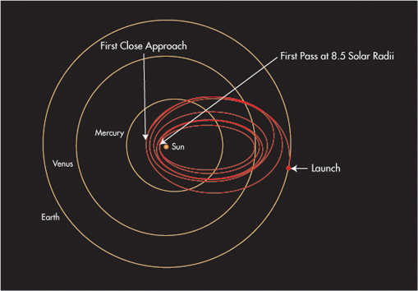

**Problem 1** – If the sun is located at the focus F1 in the diagram above, what is the distance between F1 and the left-hand point labeled ‘-a’, and the distance between the sun and the right-hand point ‘a’ on the orbit of the Parker Solar Probe?

Answer: The distance from F1 to –a is called the perihelion and measures 7 million km. The distance from F1 to a is the farthest distance the spacecraft can get from the sun and is called the aphelion, which is 110 million km.

**Problem 2** – What is the length of the semi-major axis given by a, for the Parker Solar Probe orbit?

Answer: 2a = the sum of the perihelion and aphelion distances or 117 million km. So a = 117/2 = **58.5 million km**.

**Problem 3** – What is the value for ‘f’ on the Parker Solar Probe orbit?

Answer: f = a – perihelion distance =58.5 – 7 = **51.5 million km**.

**Problem 4** – What is the value for ‘e’, the eccentricity of the ellipse?

Answer: e = f/a = 51.5/58.5 = **0.88**

**Problem 5** – Write the equation of the elliptical orbit in Standard Form using the distance unit of 1 AU = 149 million km for the variables x and y.

Answer: x2/a2 + y2/b2 = 1

Changing units to AUs, we get a = 58.5 million/149 million = 0.39.

b = 1/2a = 0.39/2 = 0.19

x2/(0.39)2 + y2/(0.19)2 = 1 so **x2/0.15 + y2/0.036 = 1**

**Problem 6** – If the orbit period, P, of the Parker Solar Probe is given by P2 = a3 with P in units of years and a in units of AU, what is the orbit period of the spacecraft in days?

Answer: P2 = (0.39)3 so P2 = 0.059 and so P = 0.24 years.

1 year = 365 days so **P = 88 days.**

**Problem 7** – What is the orbit period of Venus in days if for Venus, a = 110 million km?

Answer: a = 110 million/149 million = .74 AU, so P2 = (0.74)3 and so

P = 0.67 years or **244 days**.

Answer Key