Exploring Interplanetary Dust with the ***Parker*** ***Solar Probe***

The FIELDS instrument on the Parker Solar Probe will make direct measurements of electric and magnetic fields, radio emissions, and shock waves which course through the sun's atmospheric plasma. FIELDS also turns the spacecraft into a giant dust detector, registering voltage signatures when specks of space dust hit the spacecraft’s antenna.

**Problem 1** – Astronomical models of interplanetary dust predict that near perihelion, the flux of dust grains with a diameter of 1 micron will be about 0.005 dust grains/meter2 per second. Near aphelion at the orbit of Venus the flux will drop to about 0.0008 dust grains/meter2 per second. If the Parker Solar Probe spends 10 days near the perihelion distance, and 20 days near aphelion each orbit, about how long between dust grain impacts will it be if the instrument collecting area is 140 cm2?

**Problem 2** – Each impact will produce a crater about 10 microns in diameter. What percentage of the surface area of the detector will be cratered after the mission completes 24 orbits?

The Parker Solar Probe spacecraft will go closer to the Sun than any manmade object has gone before, which has required the development of new thermal and micrometeoroid protection technologies.

During the 24 solar orbits of the mission, the spacecraft will encounter a thermal environment that is 50 times more severe than any previous spacecraft. It will also travel through a dust environment previously unexplored, and be subject to particle hypervelocity impacts at speeds much faster than anything previously encountered by NASA spacecraft.

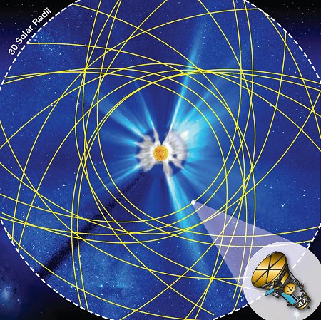

Spacecraft orbits near the sun

**Problem 1** – Astronomical models of interplanetary dust predict that near perihelion, the flux of dust grains with a diameter of 1 micron will be about 0.005 dust grains/meter2 per second. Near aphelion at the orbit of Venus the flux will drop to about 0.0008 dust grains/meter2 per second. If the Parker Solar Probe spends 10 days near the perihelion distance, and 20 days near aphelion, about how long between dust grain impacts will it be if the instrument collecting area is 140 cm2?

Answer: The collecting area is 140 cm2 x (1 meter2/10000cm2) = 0.014 meters2, so the dust grain fluxes result in 0.005 x 0.014 = 0.00007 impacts per second at perihelion, and 0.00008 x 0.014 = 0.0000011 impacts per second at aphelion. The time between impacts is just the reciprocal of these rates or about 1 impact every 4 hours at perihelion, and one impact every 252 hours at aphelion. During the times spent at each distance, at perihelion there will be about 10days x24hrs /4hrs = **60 impacts**. For the 20 days spent at aphelion, 20 days x 24 hrs/252 hrs = **2 impacts.**

**Problem 2** – Each impact will produce a crater about 10 microns in diameter. What percentage of the surface area of the detector will be cratered after the mission completes 24 orbits?

Answer: The area of the detector is 0.014 meters2. Each circular crater has an area of  (10x10-6 meters/2)2 = 7.9x10-11 meters2. At perihelion there are 60 impacts per orbit so there will be a total of 60x24 = 1440 impacts, each with an area of 7.9x10-11 meters2, for a total area of 1.1x10-7 meters2. The percentage of area cratered is then 100% (1.1x10-11/0.014) = **0.0008 %**.

Answer Key