Exploring Orbital Speeds with the ***Parker Solar Probe***!

The Parker Solar Probe spacecraft will be placed in a series of elliptical orbits around the sun. As the spacecraft travels around the elliptical path, its speed changes from a very fast pace nearest the sun (called the perihelion), to a very slow speed at its farthest point (called the aphelion). The speed at any distance from the sun along the orbit can be computed from the following equation:



r and a are distances in meters, and v is in meter/sec

**Problem 1** - The elliptical orbit of the Parker Solar Probe begins at Earth at aphelion, at a distance of 1.49x1011 meters, and a perihelion distance of 2.23x1010 meters. If the elliptical orbit has a semi-major axis of a = 8.57x1010 meters, what are the spacecraft speeds at perihelion and aphelion in km/sec rounded to 2 significant figures?

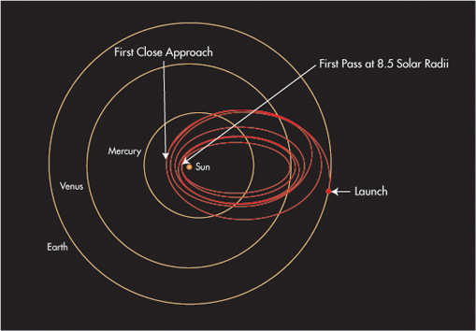

r and a are distances in meters, and v is in meter/sec

**Problem 1** - The elliptical orbit of the Parker Solar Probe begins at Earth at aphelion, at a distance of 1.49x1011 meters, and a perihelion distance of 2.23x1010 meters. If the elliptical orbit has a semi-major axis of a = 8.57x1010 meters, what are the spacecraft speeds at perihelion and aphelion in km/sec rounded to 2 significant figures?

Answer: Perihelion



= 1.15x1010 (7.8x10-11)1/2

= 1.0x105 meters/sec

= **100 km/sec.**

Aphelion:



= 1.15x1010 (1.7x10-12)1/2

= 14,994 m/sec

= **15.0 km/sec.**

Answer Key